**Test Results/Reports post execution in STS :**

**STS Server up and running:**

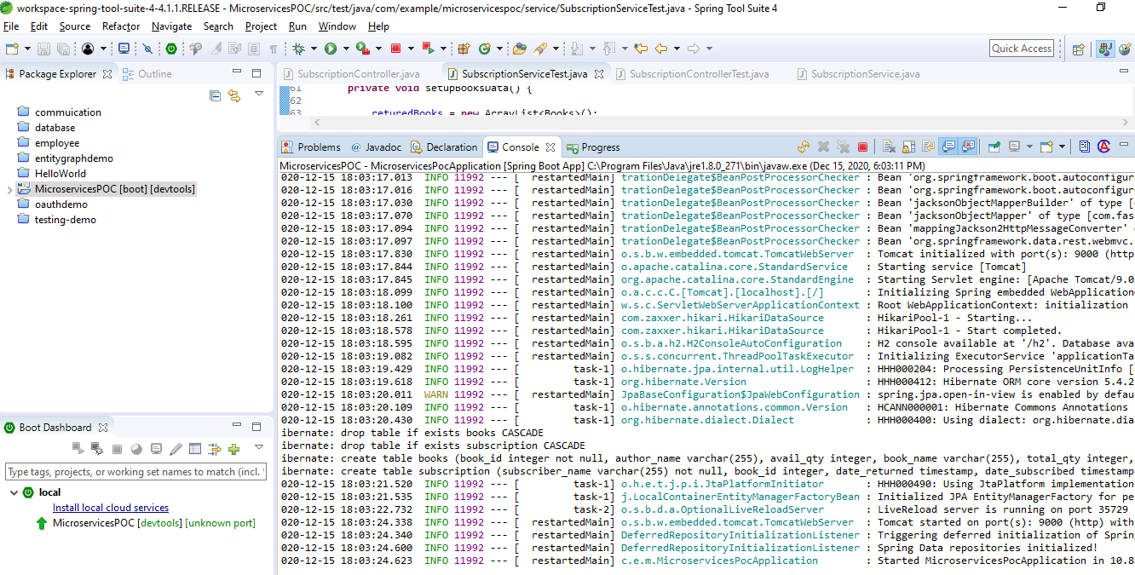

**APIs execution:**

http://localhost:9000/books

http://localhost:9000/subscriptions

http://localhost:9000/subscriptions/Subscriber1

<http://localhost:9000/books/Book1>

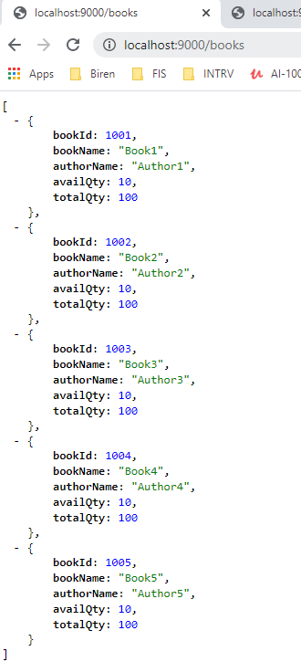

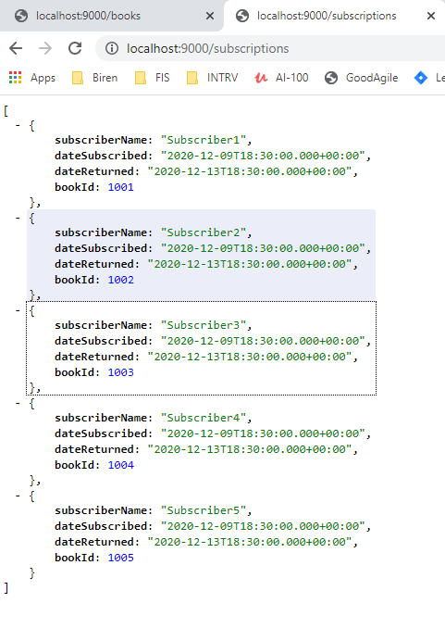

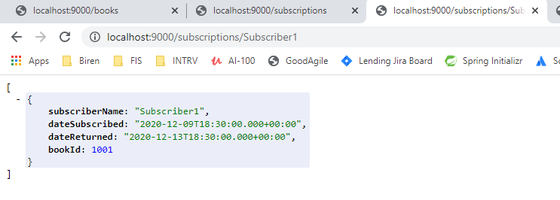

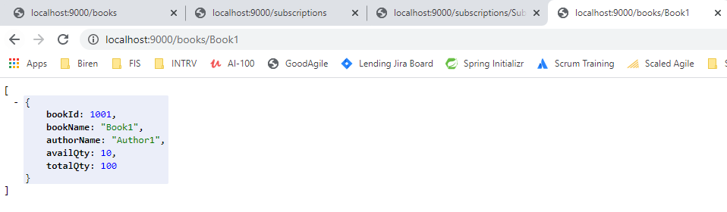

**H2 Database**

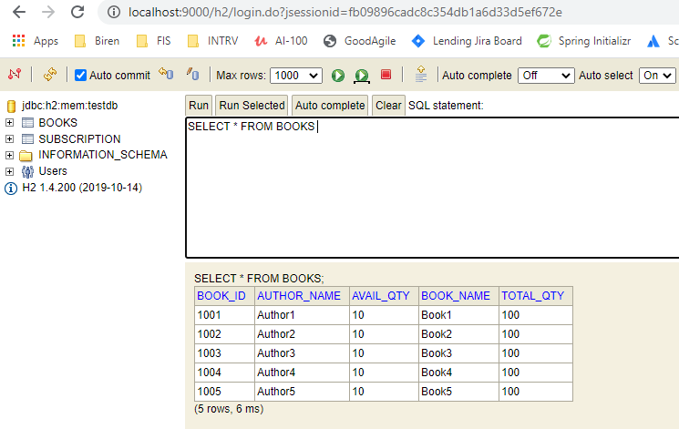

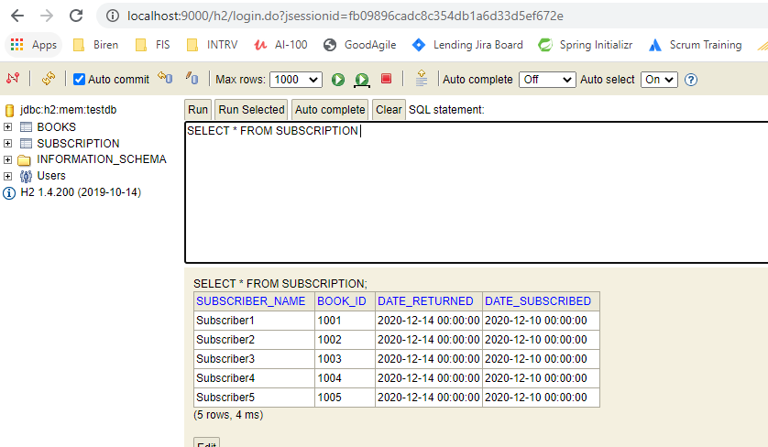

**Post running JUnit Test Cases:**

